

SPEC NO.: CU-002SDIP

Specification
TO:1123/1463
Model Name: Crystal Unit
PART NO: S3225-32.000M-9-20-20-A CUSTOMER PART NO.:

APPROVAL SHEET 样品承认书
Approved? | Yes
Approved? | No.
Customer's comments are welcomed here.

Please return this copy as a certificate of your approval by email.

Approved By Date: ______________

STRONG ELECTRONICS&TECHNOLOGY LIMITED
深圳市思硕电子科技有限公司

Tel:86-755-84528985 Fax: 86-755-84528986
Email:info@strongfirst.com.cn
www.strongfirst.com.cn

Strong Electronics&Technology Limited www.strongfirst.com.cn

Crystal Unit Specification
History Record

Date | Part No. | SPEC No. | Description. | Remarks.
2018-09-12 | S3225-32.000M-9-2 0-20-A | V1.0 | Initial issue | Xuguangdong
2024-07-29 | S3225-32.000M-9-2 0-20-A | V1.0 | Marking update | Xuguangdong
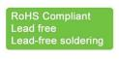 | ISO9001:2000 ISO14001:2004 | Approved by | Check by | Design by
 | ISO9001:2000 ISO14001:2004 | May-15-2007 | May-10-2005 | Jan-16-2001
Reversions | Total Page | Xu gang dong | Liu jun | Wang hon
CU-022SDIP |  | Xu gang dong | Liu jun | Wang hon

1.Range:
This specification shall cover the characteristics of Crystal Unit with Strong’s P/N:
S3225-32.000M-9-20-20-A

ROHS Compliant (Pb Free)
Small Seam sealed crystal units Surface Mount Package
High precision characteristic covering up to high frequency range
Higher frequency stability and reliability Tape and Reel packing available

2.Specification

Item | Specification
Frequency Range | 32.000MHz
Frequency Tolerance (at 25 ℃) | ±20ppm
Frequency Stability Over Operating Temperature Range | ±20ppm
Operating Temperature Range | -50 ~ +105℃ ,
Shunt Capacitance | 7.0pF
Load Capacitance | 9pF
Drive Level | 0.01μW ~ 300μW, 100μW typical
Storage Temperature Range | -55 ~ +125℃
Aging | ± 1ppm / year Max

ESR

Frequency | Mode | ESR
10.0MHz | Fundamental | 150 ohms max
11.0~ 11.9MHz | Fundamental | 120 ohms max
12.0~ 12.9MHz | Fundamental | 100 ohms max.
13.0~ 15.9MHz | Fundamental | 80 ohms max.
16.0~20.9MHz | Fundamental | 70 ohms max.
21.0~29.9MHz | Fundamental | 60 ohms max.
30.0~60.0MHz | Fundamental | 30 ohms max.
72.0~ 156.25MHz | 3rd | 100 ohms max.

3.Dimension (mm)

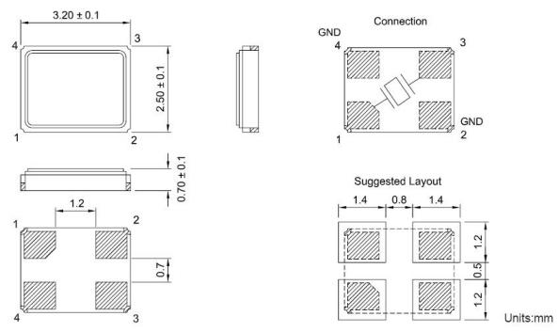

S3225-4 type 3.2mm*2.5mm

Equivalent Circuit：

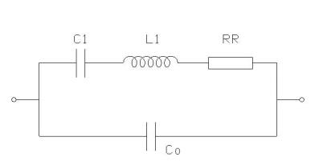

4. Marking
32.000M
5. Reliability Specification

 | Item | Condition | Standard
1. | Drop characteristics | Free drop from 75cm height on a hard wooden board for 3 times. (Board is thickness more than 30 mm.) | Frequency change: ≤±5ppm
2 | Mechanical shock | Device are shocked to half sine wave (1000g) three mutually perpendicular axes each 3 times | Frequency change: ≤±5ppm
3. | Shake  characteristics | Shake frequency 10~55Hz, cyc1~2 minutes, swing 1.5mm, direction x/y/z, all 30 minutes, test after 1 hours. | Frequency change: ≤±5ppm
4. | Humidity  characteristics | +40±2℃ & 90%~95% R.H. 250 hours | Frequency change: ≤±5ppm
5. | Low temperature characteristics | -40±2℃, 250 hours, put in room temperature, test after 1 hours. | Frequency change: ≤±5ppm
6. | High temperature characteristics | +85±2℃, 250 hours, put in room temperature, test after 1 hours. | Frequency change: ≤±5ppm
7. | Temperature cycling | -30±3℃/30±3 min~+85±2℃/30±3min,  5 cycles | Frequency change: ≤±5ppm
8. | Reflow examination | 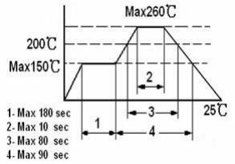 | Frequency change: ≤±5ppm

6. Packing Specification
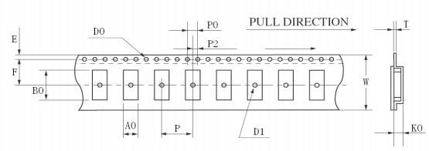
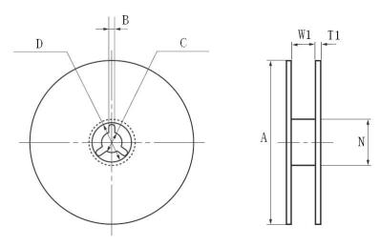

 | 49S-SMD | S8045 | S7050 | S6035 | S5032 | S4025 | *S3225
W | 24.00±0.30 | 16.00±0.05 | 16.00±0.05 | 12.00±0.05 | 12.00±0.05 | 12.00±0.05 | 12.00±0.05
E | 1.75±0.10 | 1.75±0.10 | 1.75±0.10 | 1.75±0.10 | 1.75±0.10 | 1.75±0.10 | 1.75±0.10
F | 11.5±0.10 | 7.5±0.10 | 7.5±0.10 | 5.5±0.10 | 5.5±0.10 | 5.5±0.10 | 5.5±0.10
T | 0.40±0.05 | 0.35±0.05 | 0.35±0.05 | 0.35±0.05 | 0.35±0.05 | 0.35±0.05 | 0.30±0.05
P | 12.00±0.10 | 8.00±0.10 | 8.00±0.10 | 8.00±0.10 | 8.00±0.10 | 8.00±0.10 | 8.00±0.10
P0 | 4.00±0.10 | 4.00±0.10 | 4.00±0.10 | 4.00±0.10 | 4.00±0.10 | 4.00±0.10 | 4.00±0.10
P2 | 2.00±0.10 | 2.00±0.10 | 2.00±0.10 | 2.00±0.10 | 2.00±0.10 | 2.00±0.10 | 2.00±0.10
D0 | φ1.50+0.10 | φ1.50+0.10 | φ1.50+0.10 | φ1.50+0.10 | φ1.50+0.10 | φ1.50+0.10 | φ1.50+0.10
D1 | φ1.50MIN | φ1.50MIN | φ1.50MIN | φ1.50MIN | φ1.50MIN | φ1.50MIN | φ1.50MIN
A0 | 4.60±0.10 | 4.85±0.10 | 5.40±0.10 | 3.90±0.10 | 3.60±0.10 | 2.80±0.10 | 2.85±0.10
K0 | 4.40±0.10 | 1.90±0.10 | 1.80±0.10 | 1.50±0.10 | 1. 10±0.10 | 0.90±0.10 | 0.85±0.10
B0 | 14.20±0.15 | 8.60±0.15 | 7.40±0.10 | 6.40±0.10 | 5.40±0.10 | 4.30±0.10 | 3.55±0.10
A | φ330±1.0 | φ178±2.0 | φ178±2.0 | φ178±2.0 | φ178±2.0 | φ178±2.0 | φ178±2.0
B | 2.30±0.20 | 2.00±0.50 | 2.00±0.50 | 2.00±0.50 | 2.00±0.50 | 2.00±0.50 | 2.00±0.50
C | φ13.5±0.20 | φ13.2±0.20 | φ13.2±0.20 | φ13.2±0.20 | φ13.2±0.20 | φ13.2±0.20 | φ13.2±0.20
D | φ21.5±0.20 | φ20.0±0.50 | φ20.0±0.50 | φ20.0±0.50 | φ20.0±0.50 | φ20.0±0.50 | φ20.0±0.50
N | φ100.0±0.5 | φ60.5±1.0 | φ60.5±1.0 | φ60.5±1.0 | φ60.5±1.0 | φ60.5±1.0 | φ60.5±1.0
W1 | 24.5±0.20 | 16.5±0.20 | 16.5±0.20 | 12.5±0.20 | 12.5±0.20 | 12.5±0.20 | 12.5±0.20
T1 | 2.30±0.20 | 1.80±0.20 | 1.80±0.20 | 1.80±0.20 | 1.80±0.20 | 1.80±0.20 | 1.80±0.20

© 2009 StrongFirst. All Rights Reserved.

